

**YOUTH BASEBALL & SOFTBALL**

**FROM T-BALL TO TRAVEL**

***“It’s all about the kids”***

**VISION**

It is our goal to make our programs the absolute best they can be and keeping kids in Avon Lake is a priority.

**MISSION**

To provide kids the opportunity to play and learn in a fun and safe environment.

**PURPOSE**

For kids to have fun while learning and developing baseball, softball, and lifelong skills.

Participating in youth sports can lead to immediate and long-term benefits for youth, their families, and communities. Participating in youth sports is associated with:

Mental, Emotional, And Social Health

* Lower rates of anxiety and depression
* Lower amounts of stress
* Higher self-esteem and confidence
* Reduced risk of suicide
* Less substance abuse and fewer risky behaviors
* Increased cognitive performance
* Increase creativity

Physical Health

* Increased physical activity levels
* Improved cardiovascular fitness
* Increase overall quality of life

Educational and Career Success

* Improved teamwork, social skills, and social responsibility
* Improved life skills (e.g., goal setting, time management, work ethic, empathy, negotiation)
* Increased empowerment, personal responsibility, and self-control
* Improved educational and occupational skills (e.g., determination, perseverance, grit, resilience, critical thinking)

Parents and coaches need to remember that it’s not about you; it’s about them!

* It’s ok for kids meet new friends
* It’s ok if kids make mistakes – it’s how they learn. Parents and coaches screaming and yelling doesn’t help!
* Let coaches’ coach. If you want to coach…volunteer!

The Avon Lake Parks & Recreation Department offers the following programs for baseball and softball:

Tee Ball (co-ed) Grades PK-K (ages 5-6)

Baseball

Coach Pitch – Grades 1-2

Minors – Grades 3-4

Majors – Grades 5-6

Jr. Thurman – Grades 7-9

Sr. Thurman – Grades 9-12

Travel – Ages 8U-18U

Softball

Coach Pitch – Grades 1-2

Minors – Grades 3-5

Majors – Grades 6-8

Seniors – 9-12

Travel – Ages 10U-14U

*Divisions may be altered based on registration*

**CODE OF CONDUCT**

The Avon Lake Parks & Recreation Department strives to provide recreational programs conducted in an ethical manner with traditional principles and expectations such as honesty, trust, fairness, and integrity. All participants must abide by all City, State, and Department laws, rules, policies, and procedures. Participants include, but are not limited to, all players, parents, coaches, and spectators.

Appropriate social behavior and treatment of others is expected at all times. Physical, mental, verbal, or emotional abuse will not be tolerated. Parents, coaches, and spectators need to put the emotional and physical well-being of youth participants ahead of their personal desire to win.

All participants will respect players, coaches, officials, spectators, and families at all times. All participants will respect the decisions of officials and coaches and must not engage in any violence or verbal threats or use any profanity.

Any employee of the Parks & Recreation Department shall be authorized to enforce the Code of Conduct, along with all rules and regulations applicable to the various programs, activities, and facilities. Any person acting inappropriately or disrespectfully may be subject to a revocation of the privilege of participating in department programs, activities and/or the use of facilities. Such revocation may be for whatever period of time the Parks & Recreation Director or designee shall determine appropriate, up to a permanent ban from department programs and facilities based upon the circumstances of the specific incident or occurrence.

Thank you for your cooperation and for making Avon Lake Park & Recreation Department programs and facilities a safe and enjoyable place to play!

AVON LAKE FIELD LOCATIONS

* Bleser Park – 32800 Electric Blvd
* Weiss Field – 33401 Weber Road
* Avon Lake High School – 175 Avon Belden Road

SCHEDULES

Schedules are available online at [www.avonlake.org](http://www.avonlake.org) and at the Recreation Department.

ELIGIBILITY REQUIREMENTS FOR PARTICIPATION

1. In-house division registration is based on the current grade level at the time of registration. Travel is typically based on age.
2. False Information - Periodic checks will be made of all registration details for false information. Parents may be required to furnish proof of legal Avon Lake address, age, grade level, etc. Anyone found giving false information may be immediately dismissed from the program. If a participant is found to be a non-resident they will be required to pay the difference between the resident and non-resident fee where applicable and/or be immediately dismissed from the program.
3. Suspended participants are not permitted to attend or participate in any game or practice, in any way under any condition during their suspension.
4. A suspended or ineligible player’s name must not appear on any roster or lineup. Any name appearing on the official score sheet will count as that player having played in the game. All games ineligible/suspended player participated in will be forfeited.

RULES

Tee-Ball through baseball and softball Majors divisions will play by Little League Playing Rules with modifications as noted in the Local Rules.

Jr. Thurman, Sr. Thurman, and Senior softball divisions will play by National Federation of High School Playing Rules with modifications as noted in the Local Rules.

Travel teams will play by the rules of the league in which they are participating; i.e. Cuyahoga Valley Baseball Association, Ohio Prospects League, Emerald Necklace, etc.

**LOCAL RULES**

Revised 5/12/2023

EQUIPMENT PROVIDED BY THE PARKS & RECREATION DEPARTMENT

Each head coach will receive an equipment bag with the following. Head coaches are responsible for informing the Recreation Department of any defective, broken, or missing equipment.

1. Bats
2. Batting helmets
3. Catcher’s equipment – mask, chest protector, shin guards, and catcher’s glove
4. Practice baseballs/softballs
5. Basic first aid kit and ice packs

EQUIPMENT TO BE PROVIDED BY EACH PLAYER

*Players may use their own bats and equipment if they meet the specified guidelines.*

1. Glove
2. Pants
3. Cleats
4. Protective cup (required for baseball catchers)
5. Water bottle

UNIFORM & EQUIPMENT RULES

UNIFORM

* The Recreation Department provides a team jersey and cap and is the players to keep.
* Players must wear their jersey and cap each game.
* Each player will be given a jersey with a different number than any other teammate. Players are not permitted to switch jerseys after the start of a game. If it is found that players have switched jerseys after the start of a game, the game will be declared a forfeit.
* All players in the Minors Division and older are required to wear white baseball or softball pants to create consistency within the programs in Avon Lake (not provided by the Recreation Department). All other cities Baseball pants are typically available to be purchased on-line or at any sporting goods store.
* Altering a uniform is not permitted in anyway. A player with an altered uniform will not be permitted to participate until they secure a suitable replacement uniform. The Recreation Department is not obligated to replace a uniform that has been altered. The participant is financially responsible for securing a replacement uniform.

BATTING HELMETS

1. Batting helmets must be worn at all times when a player is in play, i.e. batting, on deck, base running, or coaching a base.
2. If batting helmet is removed intentionally while in play, player is out.
3. Throwing a batting helmet may result in an immediate ejection from the game.

CATCHER’S EQUIPMENT

1. Players must wear catcher’s equipment; including a protective cup for baseball, when fielding pitches; including warm-ups.

GAME BALLS

Provided by the Recreation Department and distributed each game

* T-Ball & Rookie Baseball & Softball – Safe/Soft Level 1 (or equivalent)
* Minors & Majors Baseball – Little League stamped ball (or equivalent)
* Jr. & Sr. Thursday & Senior Softball – High School stamped ball (or equivalent)

CLEATS

* No metal cleats unless otherwise noted.

BAT RULES

Per Little League – Updated as of April 13, 2022

**Rule 1.10 – Baseball**

The bat must be a baseball bat which meets the USA Baseball Bat standard (USABat) as adopted by Little League. It shall be a smooth, rounded stick, and made of wood or of material and color tested and proved acceptable to the USA Baseball Bat standard (USABat).

Beginning with the 2018 season, non-wood and laminated bats used in the Little League (Majors) and below, Intermediate (50-70) Division, Junior League divisions, and Challenger division shall bear the USA Baseball logo signifying that the bat meets the USABat – USA Baseball’s Youth Bat Performance Standard. All BPF – 1.15 bats will be prohibited beginning with the 2018 season. Additionally, starting in 2018, the bat diameter shall not exceed 2⅝ inches for these divisions of play. Bats meeting the Batted Ball Coefficient of Restitution (BBCOR) standard may also be used in the Intermediate (50-70) Division and Junior League divisions. Additional information is available at [**LittleLeague.org/batinfo**](https://www.littleleague.org/playing-rules/bat-information/).

**Tee Ball:**

Under the USABat standard, certified Tee Ball bats (26″ and shorter) and text which reads [ONLY FOR USE WITH APPROVED TEE BALLS](https://www.littleleague.org/partnerships/licensing/baseballs-softballs/).

**NOTE:**Approved Tee Ball bats may also be used for Coach Pitch/Machine Pitch Minor Divisions only with the use of [approved Tee Balls](https://www.littleleague.org/partnerships/licensing/baseballs-softballs/).

**Minor/Major Divisions:**

It shall not be more than 33 inches in length; nor more than 2⅝ inches in diameter, and if wood, not less than fifteen-sixteenths (15/16) inches in diameter (7/8 inch for bats less than 30″) at its smallest part. Wood bats taped or fitted with a sleeve may not exceed sixteen (16) inches from the small end.

**NOTE 1:** Solid one-piece wood barrel bats do not require a USA Baseball logo.

**NOTE 2:**Approved Tee Ball bats may also be used for Coach Pitch/Machine Pitch Minor Divisions only with the use of [approved Tee Balls](https://www.littleleague.org/partnerships/licensing/baseballs-softballs/).

**Intermediate (50-70) Division and Junior League:**

It shall not be more than 34″ inches in length; nor more than 2⅝ inches in diameter, and if wood, not less than fifteen-sixteenths (15/16) inches in diameter (7/8 inch for bats less than 30″) at its smallest part. Wood bats taped or fitted with a sleeve may not exceed eighteen (18) inches from the small end.

**NOTE 1:** Solid one-piece wood barrel bats do not require a USA Baseball logo.

**NOTE 2:**Also, permitted for the Intermediate (50-70) Division and Junior League Division are bats meeting the BBCOR performance standard, and so labeled with a silkscreen or other permanent certification mark. The certification mark shall be rectangular, a minimum of a half-inch on each side and located on the barrel of the bat in any contrasting color. Aluminum/alloy and composite bats shall be marked as to their material makeup being aluminum/alloy or composite. This marking shall be silkscreen or other permanent certification mark, a minimum of one-half-inch on each side, and located on the barrel of the bat in any contrasting color.

**Senior League:**

It shall not be more than 36 inches in length, nor more than 2⅝ inches in diameter, and if wood, not less than fifteen-sixteenths (15/16) inches in diameter (7/8 inch for bats less than 30″) at its smallest part. Wood bats taped or fitted with a sleeve may not exceed eighteen (18) inches from the small end. The bat shall not weigh, numerically, more than three ounces less than the length of the bat (e.g., a 33-inch-long bat cannot weigh less than 30 ounces). All bats not made of a single piece of wood shall meet the Batted Ball Coefficient of Restitution (BBCOR) performance standard, and such bats shall be so labeled with a silkscreen or other permanent certification mark. The certification mark shall be rectangular, a minimum of a half-inch on each side and located on the barrel of the bat in any contrasting color. Aluminum/alloy and composite bats shall be marked as to their material makeup being aluminum/alloy or composite. This marking shall be silkscreen or other permanent certification mark, a minimum of one-half-inch on each side, and located on the barrel of the bat in any contrasting color.

**Rule 1.10 – Softball**

The bat must be a softball bat which meets Little League specifications and standards as noted in this rule. It shall be a smooth, rounded stick and made of wood or a material tested and proved acceptable to Little League standards. The bat shall be no more than 33 inches (34 inches for **Junior/Senior League**) in length, not more than two and one-quarter (2¼) inches in diameter, and if wood, not less than fifteen-sixteenth (15/16) inches in diameter (7/8 inch for bats less than 30 inches) at its smallest part. Non-wood bats shall be printed with a BPF (bat performance factor) of 1.20. Bats may be taped or fitted with a sleeve for a distance not exceeding 16 inches from the small end. Colored bats are acceptable. A non-wood bat must have a grip of cork, tape or composition material, and must extend a minimum of 10 inches from the small end. Slippery tape or similar material is prohibited.

**An illegal or altered bat must be removed**.

In all divisions, non-wood bat must have a grip of cork, tape, or composition material, and must extend a minimum of 10 inches from the small end. Slippery tape or similar material is prohibited.

**NOTE 1:** The traditional batting donut is not permissible.

**NOTE 2:** The use of pine tar or any other similar adhesive substance is prohibited at all levels of Little League Baseball and Softball. Use of these substances will result in the bat being declared illegal and removed from play.

**NOTE 3:** Non-wood bats may develop dents from time to time. Bats that have cracks or sharp edges, or that cannot pass through the approved Little League bat ring for the appropriate division must be removed from play. The 2¼-inch bat ring must be used for bats labeled 2¼. The 2⅝-inch bat ring must be used for bats labeled for 2⅝.

**NOTE 4:** An illegal bat must be removed. Any bat that has been altered shall be removed from play. **PENALTY** – See Rule – 6.06(d).

BASEBALL PITCHING RULES

|  |  |  |  |  |  |
| --- | --- | --- | --- | --- | --- |
| League | Daily Pitch Limit | Required Days of Rest | | | |
| 0 Days Rest | 1 Day Rest | 2 Day Rest | 3 Day Rest |
| Minors | 75 | 1-20 | 21-35 | 36-60 | 61-75 |
| Majors | 85 | 1-20 | 21-35 | 36-60 | 61-85 |
| Jr. Thurman | 95 | 1-20 | 21-35 | 36-60 | 61-95 |
| Sr. Thurman | 125 | 1-30 | 31-50 | 51-75 | 76-125 |

* All pitchers in all division must adhere to the pitch limits and required days of rest as listed above.
* The manager/coach must remove the pitcher when said pitcher reaches the limit per age group as listed above.
* A pitcher once removed from the mound cannot return as a pitcher.
* Please refer to the Little League Playing Rules, National Federation of High School Playing Rules, or other league rules pertaining to pitching rules.

SPECIAL PLAYING RULES

Each division will play by Little League Playing Rules or National Federation of High School Playing Rules with modifications as noted in the Local Rules.

ALL DIVISIONS

1. Teams must be ready to play at game time – no grace period.
2. All players are to be included in the batting order.
3. If a player is unable to bat for any reason other than illness/injury it will be an automatic out.
4. Throwing a bat will be an automatic out and may include ejection depending on severity and/or if done more than once in a game.
5. Defensive substitutions may be made at any time; batting order remains the same.
6. All players must have their uniform on including jersey tucked in, cap, and shoes tied.

**TEE BALL**

1. Grades PK-K (ages 5-6)
2. Dimensions – 60’ bases.
3. Time limit – No new inning will begin after 50 minutes; however, most games end after the second rotation of each team’s batting order has been completed.
4. Maximum number of defensive players on field – All players are in the field. A maximum of 5 players may be place defensively in the infield. Infield players should be spread out in the infield as similar to regulation baseball as possible; i.e. pitcher, first base, second base, shortstop, and third base *(no catcher).* All other players should be randomly placed throughout the outfield.
5. Rotating players – No player may play more than one inning at either pitcher or first base. Coaches are responsible for rotating players. No player can be in the same position more than 1 inning.
6. Batting – All batters will hit the ball from a batting tee. The tee should be adjusted to such a height the batter will be able to swing level. All players present for the game shall bat each inning, whether playing defensively or not. The batting order need not remain constant inning to inning.
7. Bunting is not permitted.
8. Base runners may only advance one base at a time. Exception: last batter all base runners may score.
9. Base runners will remain on base even if an out is made.
10. Play is over once a defensive player attempts to make a play on a base runner and an infielder has regained control of the ball.
11. Overthrows – Base runners are not permitted to advance on any overthrow.
12. No sliding, stealing, or leading off permitted.
13. End of Inning – After all players have batted.
14. Coaches – Offensively a maximum of 1 coach must be stationed behind the plate to load the tee and collect the balls. Defensively a maximum of 2 coaches may be stationed beyond infielders in order to provide instruction to all defensive players. There are no umpires assigned to Tee Ball.
15. Last game – Regular season games cancelled due to inclement weather will not be rescheduled except in extreme circumstances; however, all teams will play a last game so kids can experience the final game of the season.
16. Scoring/Standings/Tournament – This is a developmental league; therefore, no score or season standings will be kept. Coaches are not required to submit a line-up. There is not a tournament or play-offs at the conclusion of the regular season.

**COACH PITCH**

1. Grades 1-2.
2. The playing field – 60’ Bases.
3. Time Limit – No new inning will begin after 60 minutes of play or 6 Innings.
4. Minimum number of players to start game – 7.
5. Maximum number of defensive players on field – 10. A maximum of 6 players may be place defensively in the infield. Infield players should be spread out in the infield as similar to regulation baseball as possible; i.e. pitcher, catcher, first base, second base, shortstop, third base, and outfield positions. If a team has less than 10 players, you will still need to have a catcher as one of the position players meaning you will have fewer outfield positions filled.  Outfield will be defined as in the grass or an imaginary line approx. 20 feet beyond the baseline. Outfielders are not permitted to be in the infield.
6. Rotating players – With each new inning, coaches must rotate in extra player(s). No player is permitted to sit on the bench more than once unless special situation such as injury. No player may play more than one inning at either pitcher or first base.
7. A coach/designated parent pitches to their own team from a safe distance from the batter. The pitcher must pitch standing up and overhand.  The pitcher may not pitch from a knee.
8. If the player does not hit the ball within 5 swings or 10 total pitches the ball is to be hit off a batting tee.
9. There are no walks or strikeouts.
10. Continuous Batting Order – All players present shall bat in a continuous batting rotation whether playing defensively or not.
11. Bunting is not permitted.
12. Infield Fly – Does not apply in Coach Pitch.
13. Lead-Offs & Stealing – Is not permitted.
14. Play is over – Once a defensive player attempts to make a play on a base runner and an infielder has regained control of ball or umpire has called “time out”.
15. End of inning – After all players have batted or 3 outs.
16. Coaches – Offensively 1 coach must be stationed on the pitcher’s mound to pitch. Defensively a maximum of 2 coaches may be stationed beyond infielders in order to provide instruction to all defensive players. Both teams are asked to help retrieve balls behind home plate.
17. Last game – Regular season games cancelled due to inclement weather will not be rescheduled except in extreme circumstances; however, all teams will play a last game so kids can experience the final game of the season.
18. Scoring/Standings/Tournament – This is a developmental league; therefore, no score or season standings will be kept. Coaches are not required to submit a line-up. There is not a tournament or play-offs at the conclusion of the regular season.

**BASEBALL MINORS**

1. Grades 3-4.
2. Dimensions – 65’ bases, 46’ pitcher’s mound. The safety base will be used at first base when possible. If the safety base is in use, the runner is encouraged to use the orange base to reduce the likelihood of collision.
3. Regulation Game – 6 innings.
4. No metal spikes
5. Pre-Game Warm Up
   1. The home team shall occupy the 1st base bench.
   2. Each team is permitted 15 minutes of on-field warmup
   3. The visiting team will warmup first and the home team second so the game may start with the home team in the field first.
   4. If there is shortened warmup time, the time is to be divided equally.
6. Time Limit – No new inning will begin after 1 hour, 30 minutes of play or 6 Innings (5½ if the home team is winning).
7. Minimum number of players to start game – A team must have 8 players to start a game or the game will be declared a forfeit. If this number is reduced by 1 or more due to injury the game may be continued and finished with less than the number of starting players. If a team or teams do not meet the required number of players to start a game the game will be declared a forfeit.
8. Maximum number of defensive players on field – 9.
9. Minimum playing time
   1. All players who show up in proper uniform on time shall play a minimum of 6 defensive outs per game.
   2. A player may not sit two consecutive innings.
   3. The only acceptable grounds for not playing an individual player are disciplinary action, injury, or illness.
   4. Failure to abide by this rule will result in a two-game suspension of the offending team’s head coach and a forfeit of the game.
10. Continuous Batting Order – All players present shall bat in a continuous batting rotation whether playing defensively or not.
11. Continuous Walks – Stealing 2nd base after a walk before the next pitch is thrown is not permitted.
12. Bunting is permitted
13. Dropped Third Strike – Does not apply in the Minor League
14. Infield Fly – Does not apply in the Minor League
15. Courtesy Runner – May be used to speed up the game for when the catcher is on base and there are 2 outs.
16. Lead-Offs – Base runner may lead off after the ball crosses home plate.
17. Stealing
    1. Base runner is permitted to steal once the ball crosses home plate.
    2. Stealing home is not permitted.
    3. A base runner may steel 2nd or 3rd base on a completed pitch, passed ball, wild pitch, or overthrow back to the pitcher.
    4. A base runner may not steel home on a completed pitch, passed ball, wild pitch, or overthrow back to the pitcher.
    5. To be clear, a runner may advance to home only on a batted ball, walk or on an overthrow during the active play after a batted ball.
18. Slide – Little League does not have a “must slide” rule for a base runner sliding into home or any other base. However, any base runner is out when the runner does not slide or attempt to get around a fielder who has the ball and is waiting to make the tag. A base runner may not jump or leave their feet to avoid a tag.
19. Fake tag – A fake tag occurs when a fielder without the ball deceives the runner by impeding his/her progress (i.e. causing to slide, slow down or stop running). A fake tag is considered obstruction and the umpire is to award whatever bases will nullify the obstruction.
20. Overthrows – Runners awarded 1 base on an overthrow from the base they are going to at time ball left hand. If more than one runner, awarded according to position of lead runner. When fielder loses possession of ball on attempted tag and ball then enters dead ball area, runners awarded one base from time ball entered dead ball area.
21. End of an Inning – The inning will end after 3 outs or 6 runs are scored. The 6-run rule will cease to be in effect for each team upon declaration of the final inning by the umpire upon which no new inning can be started.
22. Keeping Score
    1. The home team is responsible for keeping the official score.
    2. The game schedule will indicate which team will act as home team.
23. Legal Game – 4 Innings (3 ½ if the home team is winning) will constitute a legal game. Games stopped because of the time limit that have not completed 4 Innings (3 ½ if the home team is winning) will count as legal games.
24. Run Rule: 15-run rule after 3 complete innings or 10-run rule after 4 complete innings – A team leads by 10 or more runs after 4 innings (3 ½ if the home team is winning) of play will be declared the winner. If the visiting team goes ahead by 10 or more runs in the top half of the 5th or 6th inning, the home team still gets to bat in the bottom half of the inning.
25. Tie Games – Regular season games ending in a tie will be counted as such.
26. League Standings will be determined based on the following point system:
    1. Two (2) points awarded for a win.
    2. One (1) point awarded for a tie.
    3. No points for a loss or forfeit.
    4. One (1) point awarded to each team for a completed game.
27. End of Season Tournament – teams will play a single elimination tournament at the end of the regular season. Tournament games ending in a tie will continue into extra innings until a winner is determined. During elimination tournament, double-headers and games on consecutive days may be necessary in order to complete the season by assigned end date. Tournament games cancelled due to inclement weather after they have begun will be rescheduled and resumed at the point they were stopped. A tournament champion will be awarded.
    1. Final round tournament games will play a regulation 6 inning game without time limit. There will be no 6-run limit per inning, however the Run Rule will remain in force.
    2. No special requests will be accepted for playoffs. Once the bracket has been posted, that will be the set schedule of events.

**BASEBALL MAJORS**

1. Grades 5-6
2. Dimensions – 65’ bases, 48' pitcher’s mound. The safety base will be used at first base when possible. If the safety bases is in use, the runner is encouraged to use the orange base to reduce the likelihood of collision.
3. Regulation Game – 6 innings.
4. No metal spikes
5. Pre-Game Warm Up
   1. The home team shall occupy the 1st base bench.
   2. Each team is permitted 15 minutes of on-field warmup
   3. The visiting team will warmup first and the home team second so the game may start with the home team in the field first.
   4. If there is shortened warmup time, the time is to be divided equally.
6. Time Limit – No new inning will begin after 1 hour, 45 minutes of play or 6 Innings (5½ if the home team is winning).
7. Minimum number of players to start game – A team must have 8 players to start a game or the game will be declared a forfeit. If this number is reduced by 1 or more due to injury the game may be continued and finished with less than the number of starting players. If a team or teams do not meet the required number of players to start a game the game will be declared a forfeit.
8. Maximum number of defensive players on field – 9.
9. Minimum Playing Time
   1. All players who show up in proper uniform on time shall play a minimum of 6 defensive outs per game.
   2. A player may not sit two consecutive innings.
   3. The only acceptable grounds for not playing an individual player are disciplinary action, injury, or illness.
   4. Failure to abide by this rule will result in a two-game suspension of the offending team’s head coach and a forfeit of the game.
10. Continuous Batting Order – All players present shall bat in a continuous batting rotation whether playing defensively or not.
11. Continuous Walks – Stealing 2nd base after a walk before the next pitch is thrown is not permitted.
12. Bunting is permitted
13. Dropped Third Strike – Does not apply in the Major League
14. Infield Fly – Applies in the Major League
15. Courtesy Runner – May be used to speed up the game for when the catcher is on base and there are 2 outs.
16. Lead-Offs – Base runner may lead off after the ball crosses home plate.
17. Stealing
    1. Base runner is permitted to steal once the ball crosses home plate.
    2. Stealing home is not permitted.
    3. A base runner may steel 2nd or 3rd base on a completed pitch, passed ball, wild pitch, or overthrow back to the pitcher.
    4. A base runner may not steel home on a completed pitch, passed ball, wild pitch, or overthrow back to the pitcher.
    5. To be clear, a runner may advance to home only on a batted ball, walk or on an overthrow during the active play after a batted ball.
18. Slide – Little League does not have a “must slide” rule for a base runner sliding into home or any other base. However, any base runner is out when the runner does not slide or attempt to get around a fielder who has the ball and is waiting to make the tag. A base runner may not jump or leave their feet to avoid a tag.
19. Fake tag – A fake tag occurs when a fielder without the ball deceives the runner by impeding his/her progress (i.e. causing to slide, slow down or stop running). A fake tag is considered obstruction and the umpire is to award whatever bases will nullify the obstruction.
20. Overthrows – Runners awarded 1 base on overthrows from the base they are going to at time ball left hand. If more than one runner, awarded according to position of lead runner. When fielder loses possession of ball on attempted tag and ball then enters dead ball area, runners awarded one base from time ball entered dead ball area.
21. End of an Inning – The inning will end after 3 outs or 6 runs are scored. The 6-run rule will cease to be in effect for each team upon declaration of the final inning by the umpire upon which no new inning can be started.
22. Keeping Score
    1. The home team is responsible for keeping the official score.
    2. The game schedule will indicate which team will act as home team.
23. Legal game – 4 Innings (3 ½ if the home team is winning) will constitute a legal game. Games stopped because of the time limit that have not completed 4 Innings (3 ½ if the home team is winning) will count as legal games.
24. Run Rule: 15-run rule after 3 complete innings or 10-run rule after 4 complete innings – A team leads by 10 or more runs after 4 innings (3 ½ if the home team is winning) of play will be declared the winner. If the visiting team goes ahead by 10 or more runs in the top half of the 5th or 6th inning, the home team still gets to bat in the bottom half of the inning.
25. Tie Games – Regular season games ending in a tie will be counted as such.
26. League Standings will be determined based on the following point system:
    1. Two (2) points awarded for a win.
    2. One (1) point awarded for a tie.
    3. No points for a loss or forfeit.
    4. One (1) point awarded to each team for a completed game.
27. End of Season Tournament – teams will play a single elimination tournament at the end of the regular season. Tournament games ending in a tie will continue into extra innings until a winner is determined. During elimination tournament, double-headers and games on consecutive days may be necessary in order to complete the season by assigned end date. Tournament games cancelled due to inclement weather after they have begun will be rescheduled and resumed at the point they were stopped. A tournament champion will be awarded.
    1. Final round tournament games will play a regulation 6 inning game without time limit. There will be no 6-run limit per inning, however the Run Rule will remain in force.
    2. No special requests will be accepted for playoffs. Once the bracket has been posted, that will be the set schedule of events.

**BASEBALL JR THURMAN**

1. Grades 7-9
2. Dimensions – 80’ bases, 54' pitcher’s mound.
3. Regulation Game – 7 innings.
4. No metal spikes
5. Pre-Game Warm Up
   1. The home team shall occupy the 1st base bench.
   2. Each team is permitted 15 minutes of on-field warmup
   3. The visiting team will warmup first and the home team second so the game may start with the home team in the field first.
   4. If there is shortened warmup time, the time is to be divided equally.
6. Time Limit – No new inning will begin after 2 hours of play from the official recorded start
7. Minimum number of players to start game – A team must have 8 players to start a game and must maintain throughout the game or the game will be declared a forfeit.
8. Maximum number of defensive players on field – 9.
9. Minimum Playing Time
   1. All players who show up in proper uniform on time shall play a minimum of 6 defensive outs per game.
   2. A player may not sit two consecutive innings.
   3. The only acceptable grounds for not playing an individual player are disciplinary action, injury, or illness.
   4. Failure to abide by this rule will result in a two-game suspension of the offending team’s head coach and a forfeit of the game.
10. Continuous Batting Order – All players present shall bat in a continuous batting rotation whether playing defensively or not.
11. Dropped Third Strike – Applies in Jr. Thurman
12. Infield Fly – Applies in Jr. Thurman
13. Courtesy Runner – May be used to speed up the game for when the catcher is on base and there are 2 outs.
14. Lead-Offs & Stealing – Permitted at any time the ball is live.
15. Slide – NFHS rule are specific and very clear – runners are never required to slide. However, if they choose to slide then the slide must be legal. A player can legally slide either feet first or head first.
16. Fake Tag – A fake tag is an act by a defensive player without the ball that simulates a tag. A fake tag is considered obstruction. When obstruction occurs, the ball becomes dead at the end of playing action and the umpire has authority to determine which base or bases shall be awarded the runners according to the rule violated.
17. Keeping Score
    1. The home team is responsible for keeping the official score.
    2. The game schedule will indicate which team will act as home team.
18. Legal Game – 5 Innings (4 ½ if the home team is winning) will constitute a legal game. Games stopped because of the time limit that have not completed 5 Innings (4 ½ if the home team is winning) will count as legal games.
19. Run Rule: 15-run rule after 4 complete innings or 10-run rule after 5 complete innings – A team leads by 10 or more runs after 5 innings (4 ½ if the home team is winning) of play will be declared the winner. If the visiting team goes ahead by 10 or more runs in the top half of the 6th or 7th inning, the home team still gets to bat in the bottom half of the inning.
20. Tie Games – Regular season games ending in a tie will be counted as such.
21. League Standings will be determined based on the following point system:
    1. Two (2) points awarded for a win.
    2. One (1) point awarded for a tie.
    3. No points for a loss or forfeit.
    4. One (1) point awarded to each team for a completed game.
22. End of Season Tournament – Teams will play a single elimination tournament at the end of the regular season. Tournament games ending in a tie will continue into extra innings until a winner is determined. During elimination tournament, double-headers and games on consecutive days may be necessary in order to complete the season by assigned end date. Tournament games cancelled due to inclement weather after they have begun will be rescheduled and resumed at the point they were stopped. A tournament champion will be awarded.
    1. No special requests will be accepted for playoffs. Once the bracket has been posted, that will be the set schedule of events.

**BASEBALL SR THURMAN**

1. Grades 9*-12
   1. 9th graders my play in Jr. Thurman or Sr. Thurman
2. Dimensions – 90’ bases, 60'6” pitcher’s mound.
3. Regulation Game – 7 innings.
4. No metal spikes
5. Pre-Game Warm Up
   1. The home team shall occupy the 1st base bench.
   2. Each team is permitted 15 minutes of on-field warmup
   3. The visiting team will warmup first and the home team second so the game may start with the home team in the field first.
   4. If there is shortened warmup time, the time is to be divided equally.
6. Time Limit – No new inning will begin after 2 hours of play from the official recorded start
7. Minimum number of players to start game – A team must have 8 players to start a game and must maintain throughout the game or the game will be declared a forfeit.
8. Maximum number of defensive players on field – 9.
9. Minimum Playing Time
   1. All players who show up in proper uniform on time shall play a minimum of 6 defensive outs per game.
   2. A player may not sit two consecutive innings.
   3. The only acceptable grounds for not playing an individual player are disciplinary action, injury, or illness.
   4. Failure to abide by this rule will result in a two-game suspension of the offending team’s head coach and a forfeit of the game.
10. Continuous Batting Order – All players present shall bat in a continuous batting rotation whether playing defensively or not.
11. Courtesy Runner – May be used to speed up the game for when the catcher is on base and there are 2 outs.
12. Slide – NFHS rule are specific and very clear – runners are never required to slide. However, if they choose to slide then the slide must be legal. A player can legally slide either feet first or head first.
13. Fake Tag – A fake tag is an act by a defensive player without the ball that simulates a tag. A fake tag is considered obstruction. When obstruction occurs, the ball becomes dead at the end of playing action and the umpire has authority to determine which base or bases shall be awarded the runners according to the rule violated.
14. Keeping Score
    1. The home team is responsible for keeping the official score.
    2. The game schedule will indicate which team will act as home team.
15. Legal Game – 5 Innings (4 ½ if the home team is winning) will constitute a legal game. Games stopped because of the time limit that have not completed 5 Innings (4 ½ if the home team is winning) will count as legal games.
16. Run Rule: 15-run rule after 4 complete innings or 10-run rule after 5 complete innings – A team leads by 10 or more runs after 5 innings (4 ½ if the home team is winning) of play will be declared the winner. If the visiting team goes ahead by 10 or more runs in the top half of the 6th or 7th inning, the home team still gets to bat in the bottom half of the inning.
17. Tie Games – Regular season games ending in a tie will be counted as such.
18. League Standings will be determined based on the following point system:
    1. Two (2) points awarded for a win.
    2. One (1) point awarded for a tie.
    3. No points for a loss or forfeit.
    4. One (1) point awarded to each team for a completed game.
19. End of Season Tournament – Teams will play a single elimination tournament at the end of the regular season. Tournament games ending in a tie will continue into extra innings until a winner is determined. During elimination tournament, double-headers and games on consecutive days may be necessary in order to complete the season by assigned end date. Tournament games cancelled due to inclement weather after they have begun will be rescheduled and resumed at the point they were stopped. A tournament champion will be awarded.
    1. No special requests will be accepted for playoffs. Once the bracket has been posted, that will be the set schedule of events.

**SOFTBALL MINORS**

1. Grades 3-5
2. Field Dimensions
3. Base length: 60 feet
4. Pitcher’s rubber to home: 35 feet
5. A player *may* move up as long as pitching motion completes inside the pitching circle.
6. Pitching circle: 8 foot radius around pitching rubber
7. In Game Rules
8. Continuous Batting Order - All team members will bat in a continuous batting rotation
9. Continuous Walk – In the Minor League, a walked batter may not immediately steal 2nd base if the catcher does not return the ball to the pitcher in time.
10. Courtesy Runner – may be used to speed up the game for when the catcher is on base and there are 2 outs.
11. Defensive Positions
12. 10 players in the field to include 4 outfielders
13. Outfielders must be on outfield grass at least 12 ft. from the infield during a pitch.
14. Defensive substitutions are free except that a removed pitcher may not assume the catching position in the same inning removed.
15. Dropped Third Strike – Does not apply in the Minor League
16. Hit Batter – a direct pitch or ball bouncing and hitting the batter awards the hitter first base.
17. Infield Fly Rule – Does not apply in the Minor League.
18. Lead Offs
19. Lead-offs are not permitted until the ball crosses home plate. Players leaving early will be sent back to the original base.

Maximum Batters

1. Play continues in an inning until 3 outs are recorded or 5 runs are scored.
2. Mercy Rule
3. If a team is leading by at least fifteen (15) runs after 3 innings or ten (10) runs or more after four (4) or more innings have been played, the game shall be terminated and the leading team declared the winner.
4. The bottom half of the inning need not be played or completed if the home team achieves such a lead.
5. Equal number of bats unless the lead is by the home team.
6. On Deck – There is no on-deck circle. Players may not practice swinging until stepping into the batter’s box.
7. Pitching – There is no restriction on number of pitches per game or week but managers are encouraged to develop multiple pitchers for the betterment of the game.
8. A third or fourth grader must pitch at least 3 outs or to 3 consecutive batters in every game.
9. The pitcher must use the windmill or slingshot motion to deliver the pitch.
10. Pitchers are allowed 8 warm-up pitches for their first inning of pitching. After their first inning, 5 warmup pitches are allowed.
11. When the ball is in the possession of the pitcher within the pitching circle, play is stopped and the ball is dead. If a base runner has committed to the next base, she may continue to that base at the risk of being thrown out. The ball remains dead until the ball is pitched and crosses home plate.
12. Sliding
13. Defensive players may not stand on home plate or any other base without the ball.
14. Requirement to slide
15. Runners are never required to slide, but to avoid interference or malicious contact the runner elects to slide, the slide must be legal.
16. Diving or hurdling a player or jumping over the outstretched glove of a fielder at any base is prohibited.
17. Any infraction of the above results in the runner being called out.
18. Umpire determines whether a slide is legal or not.
19. Stealing
20. Stealing is permitted for 2nd and 3rd base once the ball crosses home plate.
21. Stealing home plate is forbidden unless a pickoff play is attempted by the pitcher or catcher of the runner at 3rd base.
22. When stealing 2nd or 3rd, and an error occurs, the runner may not attempt to take the next base.
23. A runner can only advance home on a batted ball.
24. League Standings
25. League standings will be determined on a point system.
26. Two (2) points are awarded for a win.
27. One (1) point is awarded for a tie.
28. There are no points for a loss or forfeit.
29. One (1) point is awarded to each team for a complete game.
30. Post-Game – All teams shall leave the dugout as clean as or cleaner than when they arrived.

Playoffs

1. End of Season Tournament – Teams will play a single elimination tournament at the end of the regular season. Tournament games ending in a tie will continue into extra innings until a winner is determined. During elimination tournament, double-headers and games on consecutive days may be necessary in order to complete the season by assigned end date. Tournament games cancelled due to inclement weather after they have begun will be rescheduled and resumed at the point they were stopped. A tournament champion will be awarded.
   1. Final round tournament games will play a regulation 6 inning game without time limit. There will be no 6-run limit per inning, however the Run Rule will remain in force.
   2. No special requests will be accepted for playoffs. Once the bracket has been posted, that will be the set schedule of events.

**SOFTBALL MAJORS**

1. Grades 6-8
2. Dimensions – 60’ bases, 40' pitcher’s mound. The safety base will be used at first base when possible. If the safety bases is in use, the runner is encouraged to use the orange base to reduce the likelihood of collision.
3. Regulation Game – 6 innings.
4. Pre-Game Warm Up
   1. The home team shall occupy the 1st base bench.
   2. Each team is permitted 15 minutes of on-field warmup
   3. The visiting team will warmup first and the home team second so the game may start with the home team in the field first.
   4. If there is shortened warmup time, the time is to be divided equally.
5. Time Limit – No new inning will begin after 1 hour, 45 minutes of play or 6 Innings (5½ if the home team is winning).
6. Minimum number of players to start game – A team must have 8 players to start a game or the game will be declared a forfeit. If this number is reduced by 1 or more due to injury the game may be continued and finished with less than the number of starting players. If a team or teams do not meet the required number of players to start a game the game will be declared a forfeit.
7. Maximum number of defensive players on field – 10.
8. Minimum Playing Time
   1. All players who show up in proper uniform on time shall play a minimum of 6 defensive outs per game.
   2. A player may not sit two consecutive innings.
   3. The only acceptable grounds for not playing an individual player are disciplinary action, injury, or illness.
   4. Failure to abide by this rule will result in a two-game suspension of the offending team’s head coach and a forfeit of the game.
9. Continuous Batting Order – All players present shall bat in a continuous batting rotation whether playing defensively or not.
10. Upon the 10th batter coming to the plate, the hitting team must announce the 10th batter and two out situation results.
11. Continuous Walks – Stealing 2nd base after a walk before the next pitch is thrown is not permitted.
12. Bunting is permitted
13. Dropped Third Strike – Does apply in the Major League
14. Infield Fly – Applies in the Major League
15. Courtesy Runner – May be used to speed up the game for when the catcher is on base and there are 2 outs.
16. Lead-Offs – Base runner may lead off after the ball leaves the pitchers hand.
17. Stealing
    1. Base runner is permitted to steal once the ball leaves the pitchers hand
    2. Stealing home is permitted.
    3. A base runner may steel 2nd or 3rd base on a completed pitch, passed ball, wild pitch, or overthrow back to the pitcher.
18. Slide – Little League does not have a “must slide” rule for a base runner sliding into home or any other base. However, any base runner is out when the runner does not slide or attempt to get around a fielder who has the ball and is waiting to make the tag. A base runner may not jump or leave their feet to avoid a tag.
19. Fake tag – A fake tag occurs when a fielder without the ball deceives the runner by impeding his/her progress (i.e. causing to slide, slow down or stop running). A fake tag is considered obstruction and the umpire is to award whatever bases will nullify the obstruction.
20. Pitcher Possession- When the ball is in the possession of the pitcher within the pitching circle, play is stopped and the ball is dead. If a baserunner has committed to the next base, she may continue to that base at the risk of being thrown out.
21. Keeping Score
    1. The home team is responsible for keeping the official score.
    2. The game schedule will indicate which team will act as home team.
22. Legal game – 4 Innings (3 ½ if the home team is winning) will constitute a legal game. Games stopped because of the time limit that have not completed 4 Innings (3 ½ if the home team is winning) will count as legal games.
23. Run Rule: 15-run rule after 3 complete innings or 10-run rule after 4 complete innings – A team leads by 10 or more runs after 4 innings (3 ½ if the home team is winning) of play will be declared the winner. If the visiting team goes ahead by 10 or more runs in the top half of the 5th or 6th inning, the home team still gets to bat in the bottom half of the inning.
24. Tie Games – Regular season games ending in a tie will be counted as such.
25. League Standings will be determined based on the following point system:
    1. Two (2) points awarded for a win.
    2. One (1) point awarded for a tie.
    3. No points for a loss or forfeit.
    4. One (1) point awarded to each team for a completed game.
26. End of Season Tournament – teams will play a single elimination tournament at the end of the regular season. Tournament games ending in a tie will continue into extra innings until a winner is determined. During elimination tournament, double-headers and games on consecutive days may be necessary in order to complete the season by assigned end date. Tournament games cancelled due to inclement weather after they have begun will be rescheduled and resumed at the point they were stopped. A tournament champion will be awarded.
    1. Final round tournament games will play a regulation 6 inning game without time limit. There will be no 6-run limit per inning, however the Run Rule will remain in force.
    2. No special requests will be accepted for playoffs. Once the bracket has been posted, that will be the set schedule of events.

**SOFTBALL SENIORS**

1. Grades 9-12
2. Dimensions – 60’ bases, 43’ pitcher’s mound.
3. Regulation Game – 7 innings.
4. Pre-Game Warm Up
   1. The home team shall occupy the 1st base bench.
   2. Each team is permitted 15 minutes of on-field warmup
   3. The visiting team will warmup first and the home team second so the game may start with the home team in the field first.
   4. If there is shortened warmup time, the time is to be divided equally.
5. Time Limit – No new inning will begin after 2 hours of play from the official recorded start
6. Minimum number of players to start game – A team must have 8 players to start a game and throughout the game or the game will be declared a forfeit.
7. Maximum number of defensive players on field – 9.
8. Minimum Playing Time
   1. All players who show up in proper uniform on time shall play a minimum of 6 defensive outs per game.
   2. A player may not sit two consecutive innings.
   3. The only acceptable grounds for not playing an individual player are disciplinary action, injury, or illness.
   4. Failure to abide by this rule will result in a two-game suspension of the offending team’s head coach and a forfeit of the game.
9. Continuous Batting Order – All players present shall bat in a continuous batting rotation whether playing defensively or not.
10. Courtesy Runner – May be used to speed up the game for when the catcher is on base and there are 2 outs.
11. Slide – NFHS rule are specific and very clear – runners are never required to slide. However, if they choose to slide then the slide must be legal. A player can legally slide either feet first or head first.
12. Fake Tag – A fake tag is an act by a defensive player without the ball that simulates a tag. A fake tag is considered obstruction. When obstruction occurs, the ball becomes dead at the end of playing action and the umpire has authority to determine which base or bases shall be awarded the runners according to the rule violated.
13. Drop Third Strike is in effect.
14. 10th Batter Rule – The hitting team bust announce the 10th batter and a two out situation results
15. Keeping Score
    1. The home team is responsible for keeping the official score.
    2. The game schedule will indicate which team will act as home team.
16. Legal Game – 5 Innings (4 ½ if the home team is winning) will constitute a legal game. Games stopped because of the time limit that have not completed 5 Innings (4 ½ if the home team is winning) will count as legal games.
17. Run Rule: 15-run rule after 4 complete innings or 10-run rule after 5 complete innings – A team leads by 10 or more runs after 5 innings (4 ½ if the home team is winning) of play will be declared the winner. If the visiting team goes ahead by 10 or more runs in the top half of the 6th or 7th inning, the home team still gets to bat in the bottom half of the inning.
18. Tie Games – Regular season games ending in a tie will be counted as such.
19. League Standings will be determined based on the following point system:
    1. Two (2) points awarded for a win.
    2. One (1) point awarded for a tie.
    3. No points for a loss or forfeit.
    4. One (1) point awarded to each team for a completed game.
20. End of Season Tournament – Teams will play a single elimination tournament at the end of the regular season. Tournament games ending in a tie will continue into extra innings until a winner is determined. During elimination tournament, double-headers and games on consecutive days may be necessary in order to complete the season by assigned end date. Tournament games cancelled due to inclement weather after they have begun will be rescheduled and resumed at the point they were stopped. A tournament champion will be awarded.
    1. Final round tournament games will play a regulation 6 inning game without time limit. There will be no 6-run limit per inning, however the Run Rule will remain in force.
    2. No special requests will be accepted for playoffs. Once the bracket has been posted, that will be the set schedule of events.

**GENERAL REGULATIONS**

CONCUSSION REGULATIONS

All volunteer athletic coaches need to take the concussion training available online at http://www.nfhslearn.com/electiveDetail.aspx?courseID=38000. The training is free. A copy of your certificate of completion must be turned into the Parks and Recreation Department office prior to coaching your first game. Parents are required to receive the Ohio Department of Health Concussion Information Sheet for Youth Sports Organizations. (see appendix)

Any athlete who exhibits signs, symptoms or behaviors consistent with a concussion (such as loss of consciousness, headache, dizziness, confusion or balance problems) shall be immediately removed from the contest and shall not return to play until cleared with written authorization by an appropriate health care professional. In Ohio, an “appropriate health care professional” shall be a physician, as authorized under ORC Chapter 4731 and includes both doctors of medicine (M.D.) and doctors of osteopathy (D.O.) and an athletic trainer, licensed under ORC Chapter 4755.

LINDSAY’S LAW

Lindsay’s Law, Ohio Revised Code [3313.5310](http://codes.ohio.gov/orc/3313.5310), [3707.58](http://codes.ohio.gov/orc/3707.58) and [3707.59](http://codes.ohio.gov/orc/3707.59) went into effect in 2017.

In accordance with this law, the Ohio Department of Health, the Ohio Department of Education, the Ohio High School Athletic Association, the Ohio Chapter of the American College of Cardiology and other stakeholders jointly developed guidelines and other relevant materials to inform and educate students and youth athletes participating in or desiring to participate in an athletic activity, their parents, and their coaches about the nature and warning signs of sudden cardiac arrest.

Coaches and parents are also required to receive handouts specific to their role (see appendix). Parents and participants are required to complete the Lindsay’s Law Parent/Athlete Signature Form (see appendix).

LIGHTNING AND INCLEMENT WEATHER

* Recognition – Recreation staff shall be educated regarding the signs indicating thunderstorm development. Since the average distance between successive lightning flashes is approximately two to three miles, ANYTIME that lightning can be seen or heard, the risk is already present.
* 30-Minute Rule – Competition or practice shall be suspended once lightning has been recognized or thunder is heard. It is required to wait at least 30 minutes after the last flash of lightning is witnessed or thunder is heard prior to resuming practice or competition. Given the average rates of thunderstorm travel, the storm should move 10-12 miles away from the area. This significantly reduces the risk of local lightning flashes. Any subsequent lightning or thunder after the beginning of the 30-minute count shall reset the clock, and another count shall begin.
* Text ALREC at 440-259-6412 to receive texts about ball field conditions, sports programs and information about current and upcoming Recreation programs.

WEATHER CANCELLATION

Cancelled games may be rescheduled at a later date if necessary. Games may be rescheduled on days a team is not regularly scheduled; i.e. Fridays, Saturdays, etc. If a game is cancelled during play and is rescheduled, it shall be resumed from the point of interruption.

GAME OFFICIALS’ RESPONSIBILITIES

1. The home plate umpire will be in charge of the game at all times.
2. The home plate umpire will review basic rules before each game with the coaches of each team. Coaches should remind their players of these rules.
3. In all disputes, only the head coach is permitted to discuss the situation, in a respectable manner, with the home plate umpire. This must be done when time is “out”.
4. The game officials are required to file an ejection card with the Recreation Department any time a coach or player receives said penalty. In some cases, an additional written report may be required.

FIELD SUPERVISOR/ATTENDENT RESPONSIBILITIES

1. To serve as an on-site supervisor and enforce all policies, procedures, rules or regulations.
2. Attending games as assigned and reporting the status of games and facility conditions.
3. Overseeing and supervising coaches, players, parents, spectators and staff.
4. Has the authority to address a coach, players, parent or spectator any time before, during or after a game, practice or team activity if a coach, player, parent or spectator is not abiding by all expectations, policies, procedures, rules or regulations of the program. If necessary, the Field Supervisor/Attendant has the authority to take immediate corrective action.
5. Does not have the authority to overturn a judgment call made by an umpire.
6. Maintain communication between the Parks & Recreation Department and coaches, players, parents, spectators and staff. Coaches, players, parents, spectators, and game officials can and should approach Field Supervisors/Attendants with all questions, comments, and concerns. Field Supervisors are there to help everyone and make sure games run smoothly.

BENCH & CROWD BEHAVIOR

1. Only members of the team and the coaching staff (maximum 3 coaches) shall be on the bench or in the bench area. All players not in the game must remain seated and/or within the bench during play.
2. Bat Boys/Girls are not permitted.
3. Coaches, players, parents and spectators shall focus their energies on player participation, team play, and sportsmanship. Coaches, players, parents, and spectators shall not engage in unsportsmanlike conduct, especially towards game officials. Coaches are responsible for controlling their parents and spectators. Failure to do so could result in removal of the coach, parent or spectator from the game. Coaches are urged to keep players from climbing, hanging or damaging the fences.

CASUAL PROFANITY

Casual profanity is defined as language which may offend others, however to a degree not deemed serious enough to warrant ejection. If in the official’s judgment any coach or player uses casual profanity, the following penalty may be invoked:

1. If by an offensive player, the next batter due up will be called “out”. If it occurs after the third out, the first batter if the next inning is called “out”. A player may be called “out” for his/her own profanity if he is the next batter or already in the batter’s box prior to putting the ball in play.
2. If by defensive player, the first batter of the next inning is called “out”.
3. This is a delayed dead ball situation and does not affect any play currently in progress. An ejection due to casual profanity is a judgment call and may not be protested.

REPORTING SCORES/PITCH COUNTS

1. The winning team must report the score to the league director
2. Pitch counts must be recorded and reported to the league director after each game (baseball only)

TOBACCO, ALCOHOL, AND ILLEGAL DRUGS

1. Tobacco – Participants (coaches, players, etc.) and contest officials in an athletic contest are prohibited from using any form of tobacco at the playing site. Penalty for violation is disqualification from that contest. Violations by contest officials shall be reported to the Avon Lake Parks & Recreation Department.
2. Alcohol and Illegal Drugs – The sale of, the distribution of, or the consumption of alcoholic beverages or illegal drugs is not permitted at the playing site of any contest. Individuals who violate this rule will be suspended indefinitely. For the safety of all concerned; game officials may deny any coach and/or player the right to participate if the game officials suspect the coach and/or player is under the influence of alcohol or drugs.

EJECTIONS

1. Ejection Process - Any participant (coach, player, parent or spectator) ejected from a game for unsportsmanlike conduct will draw an automatic 2-game suspension from the next actual game played by their own team and may be suspended for additional time if warranted by the offense. Forfeited, postponed or cancelled games are not considered actual games played.
2. A participant may be ejected before, during or after any game.
3. The ejected participant must leave the facility immediately. Any ejected participant may not be at any game site during said suspension and is ineligible to participate and/or attend any game and/or practice during said suspension. Penalty: Forfeit of game and additional suspension to be handed down from the Youth Athletic Commission, Director or designee.
4. Second Ejection - A second ejection during the season for a similar offense may result in additional suspension and may be required to appear before the Parks and Recreation Commission or designated committee.
5. Ejection from Last Game of Season - Any participant ejected from their team’s last game of the season for unsportsmanlike conduct will automatically be suspended from the first game of the next sport they participate in for the Avon Lake Recreation Department (i.e. baseball, basketball, football, etc.).
6. Confirmation of Suspension - While the Avon Lake Recreation Department sends out letters to confirm suspensions, coaches, players, parents and spectators should not wait to receive a letter before ejected participant sits out. Suspension from at least the next game is automatic.

FORFEITS

1. Shortage of Players - If a team or teams do not meet the required number of players to start a game the game will be declared a forfeit.
2. If one or both teams forfeit because they do not have the minimum number of players or other circumstances highlighted in this rulebook, the following options may be exercised at the start of a game:
   1. A practice game may be played if both teams agree to stay and play; however, the forfeit remains in effect. Game officials are not required to officiate the practice game.
   2. If both teams do not agree to play a practice game, both teams are permitted to practice. Teams must share the field and may practice for approximately 45 minutes.
3. If a game is shortened due to a player injury resulting in a forfeit due to a lack of players the game can be continued as a practice game.
4. A game may not start for any reason once it has been declared a forfeit.

PROTESTS

A protest may occur when a head coach claims an umpire’s decision is in violation with the game rules. No protest shall ever be permitted on judgment decisions by the umpire.

1. A protest must be filed immediately with the umpire before the next play of the game.
2. If a protest occurs on the final play of the game, it must be filed immediately with the umpire. The protest is not valid after the umpire leaves the field. If an umpire is working additional game(s) on the same field, the protest must be made within a reasonable amount of time and prior to the start of the next game.
3. Protests must be submitted in writing by the head coach to the Avon Lake Recreation Department within 24 hours from completion of game during the next business day. The written document must give a brief description of the play and/or incident being protested and what rule it is in violation of.
4. During tournament play, protests must be resolved at the game site by game officials. Game officials will temporarily suspend play until the situation is resolved.
5. The Avon Lake Recreation Department will not consider a protest if the above rules are not adhered to.

FIELD PERMITS FOR PRACTICES

1. Are issued by the Recreation Department.
2. Available starting May 1 and are issued in 1 to 2 hour blocks of time.

APPENDIX A – CONCUSSION PROTOCOL

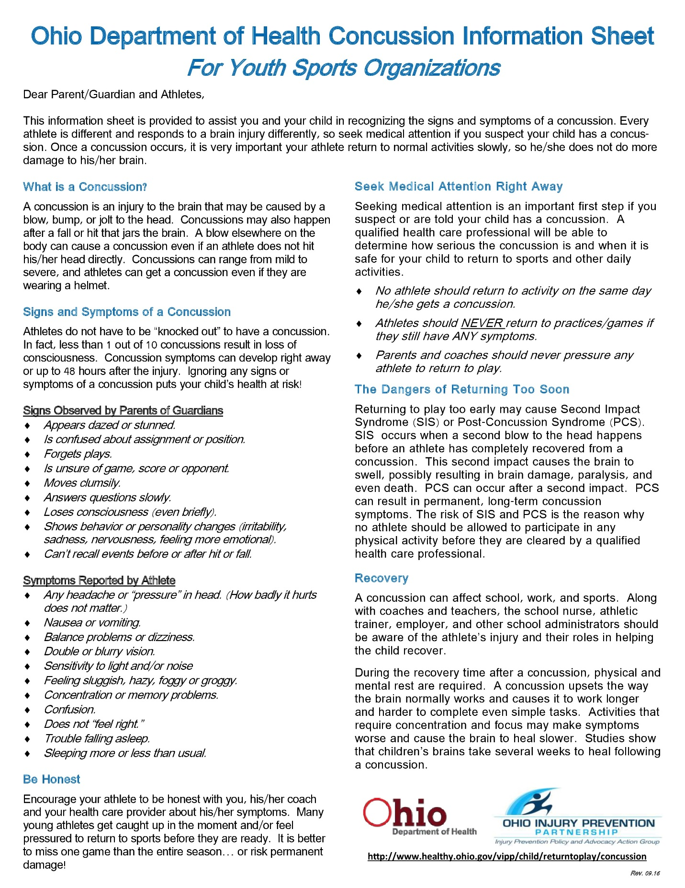

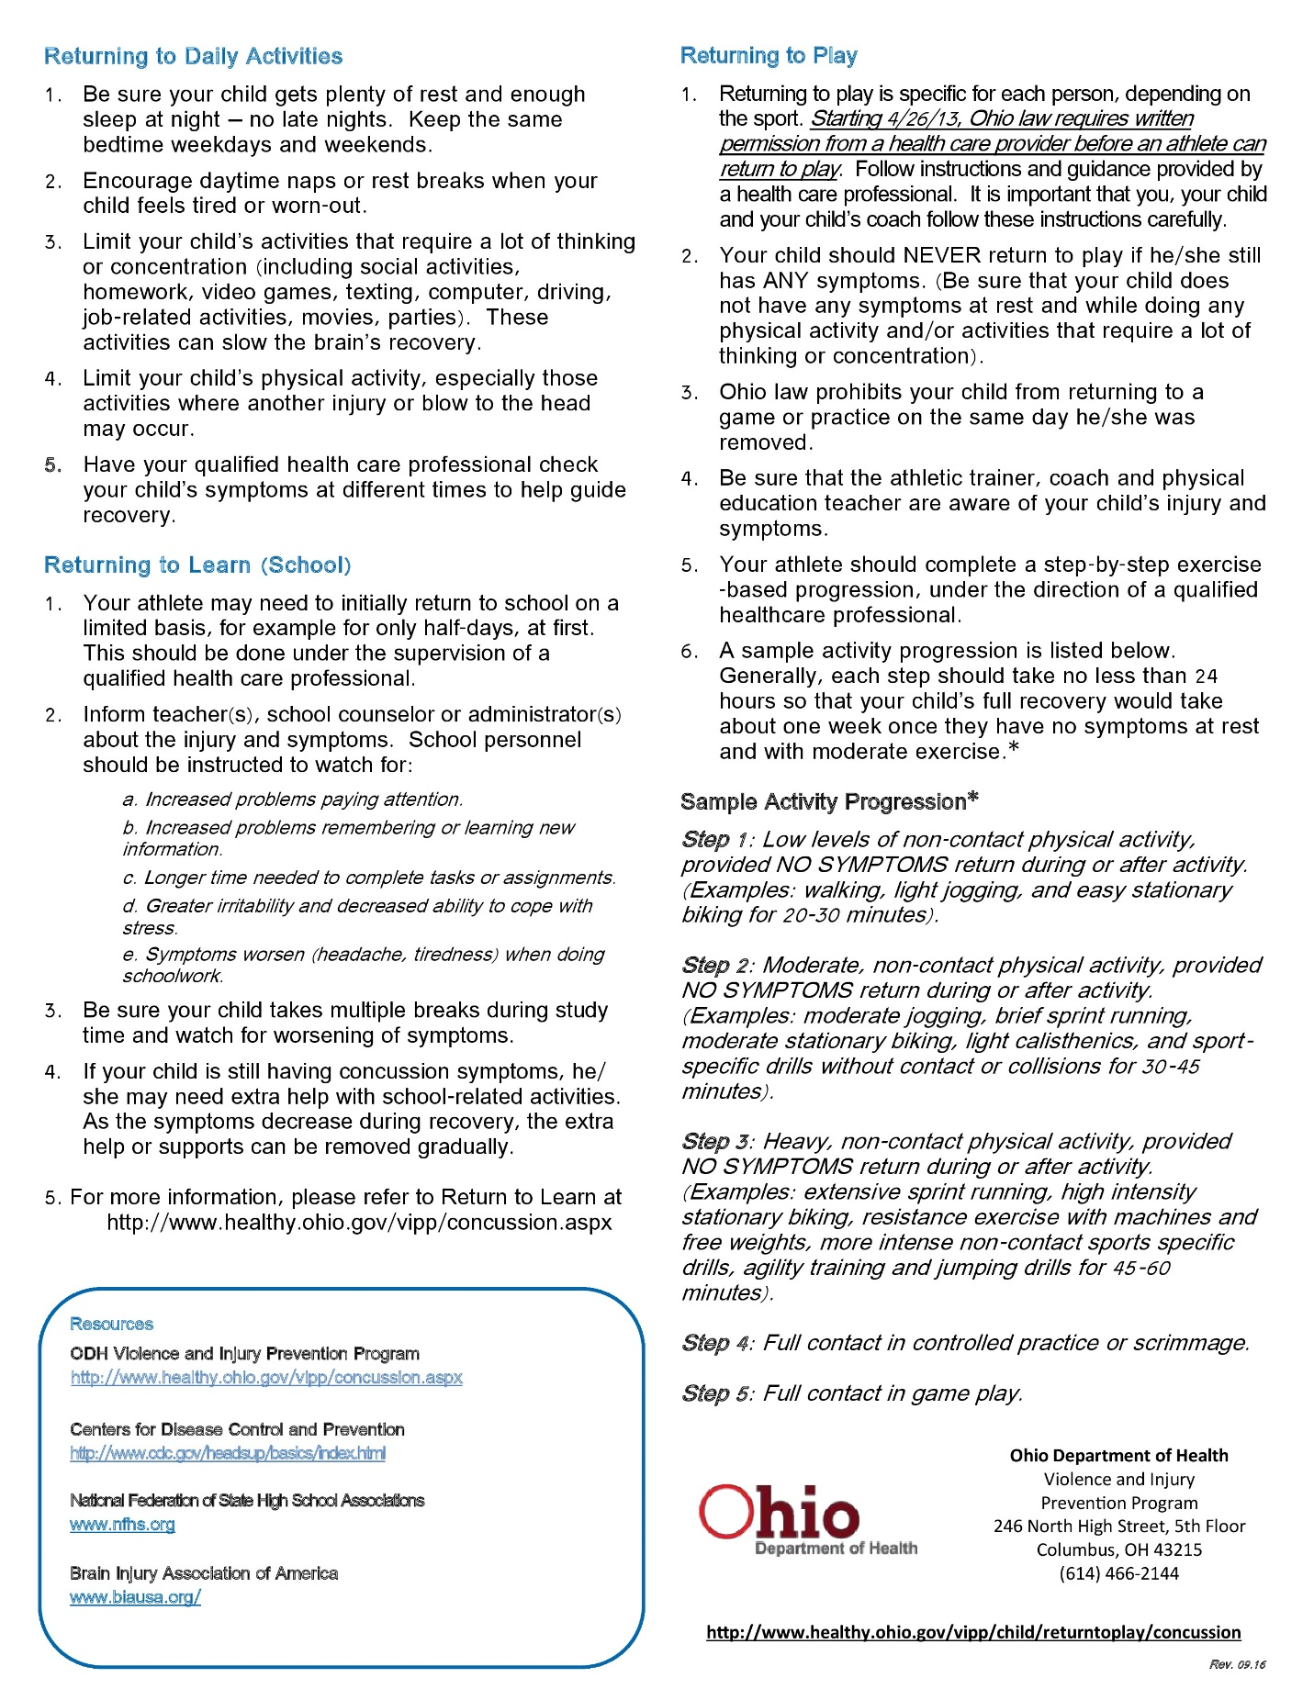

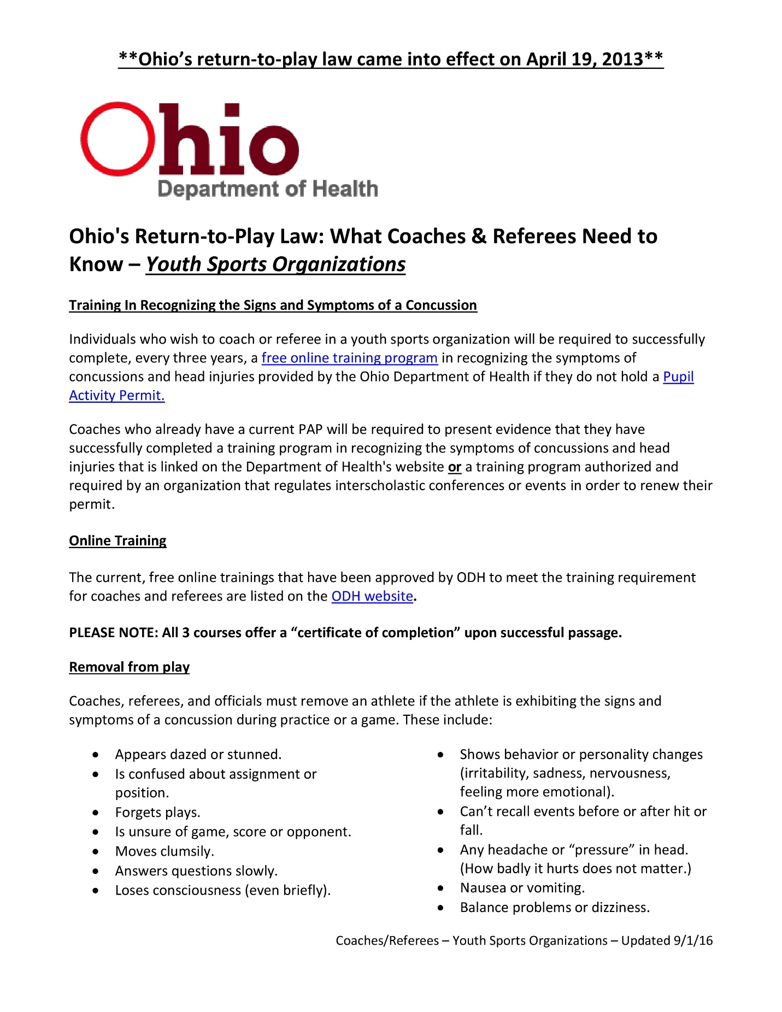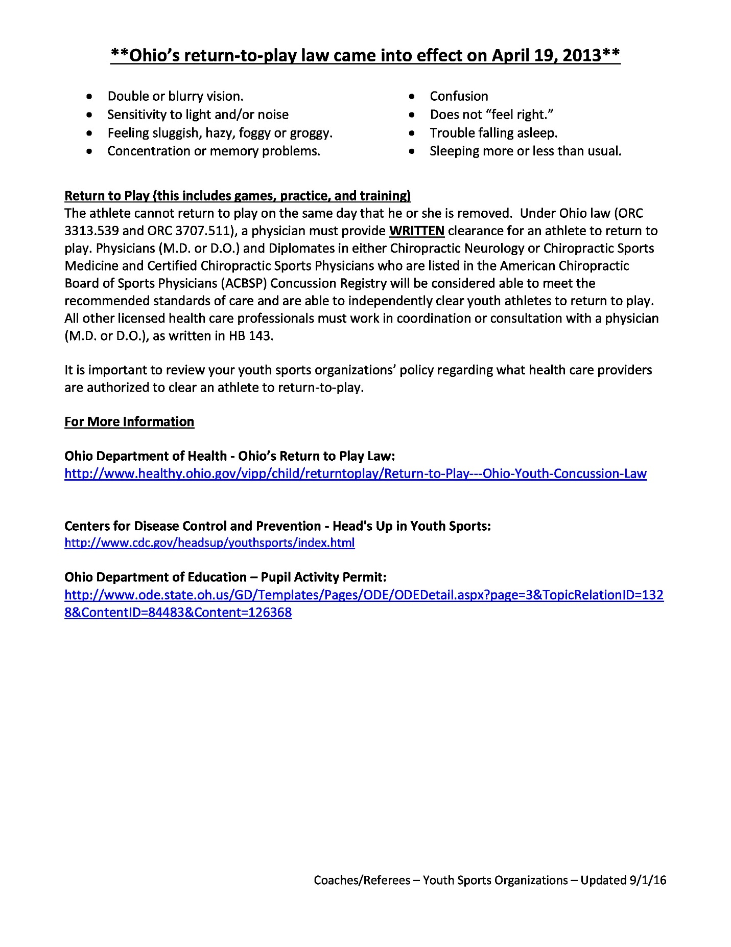

APPENDIX B – LINDSAY’S LAW

